Roomscaling vr:-

{{{{{{{

HTC Vive vs. Oculus Rift With Touch – Which Is The Better Roomscale Experience?

<https://uploadvr.com/vive-vs-oculus-rift-touch-roomscale/>

}}}}}}}}}}}}}}}}}}}}}}

{{{{{{{{{{{{{{{{{{{{{{{{{{{{{{{{{{{

[Roomscale VR with Google Daydream](https://masterofshapes.com/thelab/roomscale-google-daydream/)

HTC VIVE TRACKER + GOOGLE DAYDREAM VR

<https://masterofshapes.com/thelab/roomscale-google-daydream/>

}}}}}}}}}}}}}}}}}}}}}}}}}}}}}}}}}}}

{{{{{{{{{{{{{{{{{{{{

## [HTC Vive Tutorial for Unity](https://www.raywenderlich.com/149239/htc-vive-tutorial-unity)

<https://www.raywenderlich.com/149239/htc-vive-tutorial-unity>

}}}}}}}}}}}}}}}}}}}}}}}}}}}}}}}}}}}}}}}}}}}}}}}}}

{{{{{{{{{{{{{{{{{{{{{{{{{{{{{{{{{{

youtube tutorial:-

Vive VR Game Developer Tutorial - Part 1 - Get Unity and explore Developer Resources

<https://www.youtube.com/watch?v=rfcX07uiQmA&index=1&list=PLnaniYoE3lPtwmwlRRKUtxT9fF7I3UJfO>

}}}}}}}}}}}}}}}}}}}}}}}}}}}}}}}}}

{{{{{{{{{{{{{{{{{{{{{{{{{{{{{{{

# Affordable Room-Scale Mobile VR Arrives with NOLO Motion Tracking System

<http://vrscout.com/news/room-scale-mobile-vr-nolo-motion-tracking/>

nolovr:-

http://www.nolovr.com/

}}}}}}}}}}}}}}}}}}}}}}}}}}}}}}}}}}

{{{{{

google daydream head set:-

a video demo of the headset and the review about the headset.

<http://www.theverge.com/2016/11/10/13578012/google-daydream-view-vr-review-mobile-headset-pixel>

}}}}}}}}}}}}}}}}}}}}}}}}}}}}}}}}}}}}}}}}}}}}}}}}

{{{{{{{{

diffference between cardboard and daydream

Google provides developers with two virtual reality (VR) platforms:

🡪Cardboard, the world's most popular and accessible mobile VR platform,

🡪 Daydream, a new platform for low-latency, immersive, and interactive mobile VR. The Google VR SDKs include everything you need to develop for these platforms, including libraries, API documentation, developer samples, and design guidelines.

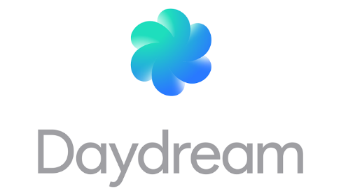 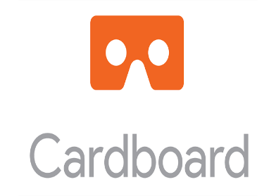

}}}}}}}}}}}}}}}}}}}}}}}}}}}}}}}}}}}}}}}}}}}}}}}}}}}}}}}}}}}}}}}}}}

[NurFACEGAMES](https://www.youtube.com/user/NurFACEGAMES)[2 months ago](https://www.youtube.com/watch?v=_YTVsLnK-XU&lc=z12jyz2rasq2wfliu04cjlrxnkyeizfxi2o.1482339329050338)

{{{{{{{{{{{

LINK FOR GOOGLE CARDBOARD SDK DOWNLOAD: AND ALSO TO IMPORT GOOGLE VR SDK TO UNITY TUTORIAL

🡪You can download previous versions here <https://github.com/googlevr/gvr-unity-sdk/commits/master> GvrViewerMain should separate from Main Camera. This video covers how to setup gvr: [https://www.youtube.com/watch?](https://www.youtube.com/watch?v=saPTSdvacLE&t=0s)

}}}}}}}}}}}}}}}}}}}}}}}}}}}}}}}}}}}}

{{{{{{{{{{{{{{{{{{{{{{{{{{{{

# Simple Scripts to Use Unity Navigation with Google Cardboard VR SDK

Download here: <https://github.com/pepwuper/Google-Cardboard-VR-Navigation>

You can also try this one - <https://github.com/shakhruz/VRToolbox>

}}}}}}}}}}}}}}}}}}}}}}}}}}}}}}

{{{{{{{{{{{{{

How to add a spatial audio:-

<https://developers.google.com/vr/concepts/spatial-audio>

}}}}}}}}}}}}}}}}}}}}}}}}}}}}}}}}}}}}}}}}}}}}}}}}

{{{{{{{{{{{{{{{

How to Developing app with daydream(googlevrsdk) ??

<https://developers.google.com/vr/daydream/hardware>

# Developer Overview(google vr)

The Google VR SDKs let you build experiences for Daydream-ready smartphones and headsets on the Android OS. Users can interact with apps using the Daydream controller. Our SDKs simplify common VR development tasks so you can focus on building your new immersive experience.

## **Hardware**

Daydream hardware consists of a VR headset and controller. Combined with a Daydream-ready phone, you can create high-quality, interactive mobile VR experiences.

Learn more about the [Daydream hardware](https://developers.google.com/vr/daydream/hardware) and how to use it for development.

# Daydream Hardware

Daydream hardware consists of a VR headset and controller. Combined with a Daydream-ready phone, you can create high-quality, interactive mobile VR experiences.

Daydream-ready headsets are designed for the high-quality mobile VR experiences that Daydream enables. Unlike the Google Cardboard viewer, they are designed for extended use. Instead of a trigger button, users interact with VR applications using the Daydream controller.

The Daydream controller was created with mobile VR in mind. Designed to be both accessible and expressive, it can track its rotation and orientation with high accuracy. It also includes a clickable touchpad and two buttons called APP and HOME. The APP button can be used by apps and the HOME button is reserved for system use.

# Developer Overview(cardboard)

The Google VR SDKs let you build experiences for Cardboard (Android and iOS). Our SDKs simplify common VR development tasks so you can focus on building your new immersive experience.

## **Hardware**

The hardware requirements for building Cardboard apps are simple and affordable: a viewer and a smartphone with Android or IOS. You don't need a separate controller; users can interact with apps through the trigger input on the viewer. You can [order an existing viewer or make your own](https://vr.google.com/cardboard/get-cardboard/index.html).

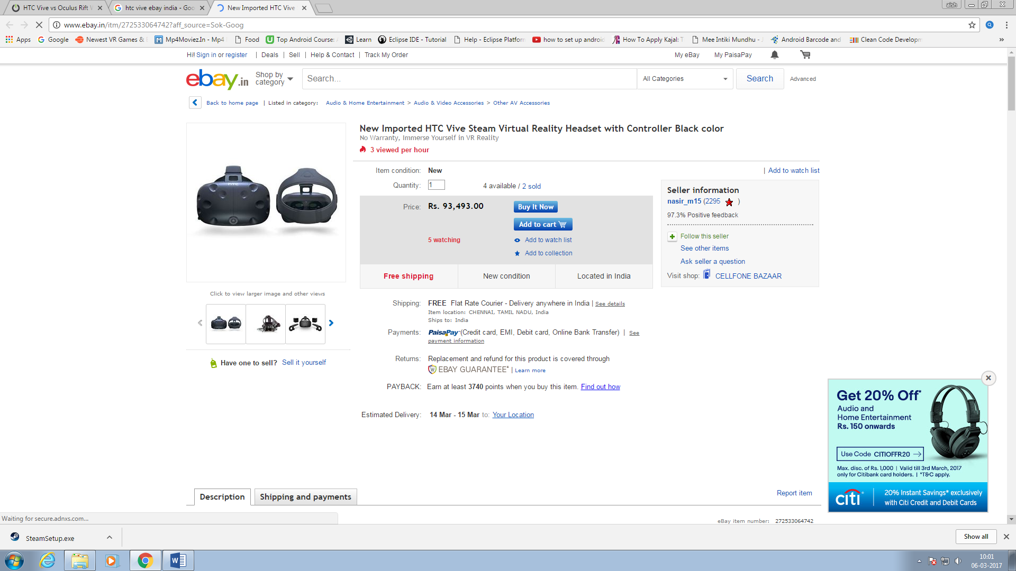

-----------------------------------------------------------------------------------------

{

Unity 5.5 works great with GoogleVR SDK, download from github. There's nothing special that needs to be done to get it compiling, works great. I recommend NOT using technical preview as there are a number of unresolved bugs. This video shows the setup:

<https://www.youtube.com/watch?v=iW0mP-hpRkk>

# }

# {

# Unity download archive

# <https://unity3d.com/get-unity/download/archive>

# }

# {

# To move objects in game tab:-

# With GoogleVR SDK, hold ALT to rotate head and hold CTRL to tilt head﻿

}

# {{{{{{

# How to publish your Unity game as a UWP app

<https://channel9.msdn.com/Blogs/One-Dev-Minute/How-to-publish-your-Unity-game-as-a-UWP-app>

}}}}}}}}}}}}}}}}}

{{{{{{{{{{{{{{{{{{{{

github for gvr sdks(1.20)

<https://github.com/googlevr/gvr-unity-sdk/commits/master>

}}}}}}}}}}}}}}}}}}}}}}}}}}}}